EzFare-Transport4you2 | Version: 1.02
Project Description | Date: 2010-10-01

EzFare- Transport4you2
Project Plan

Version 1.02

Page 1

Doc. No.:

EzFare-Transport4you2 | Version: 1.02
Project Description | Date: 2010-10-01

Revision History

Date | Version | Description | Author
2010-09-25 | 1.00 | Initial Draft | LK and FM
2010-10-01 | 1.01 | Initial Draft | LK and FM
2011-01-08 | 1.02 | Made some change | LK

Page 2

EzFare-Transport4you2 | Version: 1.02
Project Description | Date: 2010-10-01

Table of Contents

1. Introduction 4
1.1 | Purpose of this document | 4
1.2 | Intended Audience | 4
1.3 | Scope | 4
1.4 | Definitions and acronyms | 4
 | 1.4.1 Definitions | 4
 | 1.4.2 Acronyms and abbreviations | 4
1.5 | References | 4

2. Organization 5
2.1 | Project management | 5
2.2 | Project group | 5
2.3 | Steering group | 5
2.4 | Customer | 5
2.5 | Others | 5

3. Assumptions and constraints 5
3.1 | Technological | 5
3.2 | Environmental | 5
3.3 | Interpersonal | 5
3.4 | Work distribution | 6
3.5 | Casual relationships | 6
3.6 | Time | 6

4. Deliverables 6
4.1.1 Remarks 6
6. | Project risks | 7
7. | Communication | 7
8. | Configuration management | 8
9. | Project plan | 8
 | 9.1 Time schedule | 8
 | 9.1.1 Remarks | 9
 | 9.2 Activity plan | 9
 | 9.3 Financial Plan | 10
 | 9.3.1 Remarks | 10

Page 3

EzFare-Transport4you2 | Version: 1.02
Project Description | Date: 2010-10-01

1. Introduction

1.1 Purpose of this document
The purpose of this document is to describe EzFare - transport4you2 project which is part of distributed system development (DSD) course. This course is joint course between Mälardalen University (MDH) in Sweden and University of Zagreb (FER) in Croatia. This document provides the introduction of EzFare project, team and as well as roles of team members.

1.2 Intended Audience
By reading this document project stakeholders and future developers will know team organization, roles and assumption of the project. In addition it will provide deliverables and scope of the project.

1.3 Scope
This document is about organization, constraints and assumptions, technologies, project risk, deliverables, communication between project stakeholders, activity plan, and financial plan. This document doesn’t include requirement analysis and design description.

1.4 Definitions and acronyms

1.4.1 Definitions

Keyword | Definitions
Project stakeholders | Project stakeholders includes customer, steering group (Aneta Vulgarakis)  and team member)
Doodle | Doodle4Google
EzFare | EasyFare (Transport4You) project

1.4.2 Acronyms and abbreviations

Acronym or abbreviation | Definitions
MDH | Mälardalen University
FER | University of Zagreb
SVN | Subversion
UML | Unified Model Language
MVC | Model View Controller
FMs | Formal Methods

1.5 References
• Project Homepage: http://www.fer.hr/rasip/dsd/projects/transport4you2
• Project proposal: http://score-contest.org/2011/projects/DiNittoRossi.Transport4You.pdf

Page 4

EzFare-Transport4you2 | Version: 1.02
Project Description | Date: 2010-10-01

2. Organization

2.1 Project management
Faiz Ul Muram (MDH) will be project leader and Vice Šimunov (FER) will be team leader. Both of them will share equal responsibility in managing the project.

2.2 Project group

Name | Initials | Responsibility (roles)
Faiz UL Muram | FM | Project leader, Designer, Developer
Kaushik Mohanraj | KM | Documentation manager, Developer
Lidia Tesfazghi | LT | SVN manager, FMs, Documentation
Mislav Stipetić | MS | System administrator, Developer, Tester
Shah Md. Shamsul Alam | SA | Database administrator, Developer, Tester
Vice Šimunov | VS | Team leader, Customer communicator, Developer

2.3 Steering group
Supervisor - Aneta Vulgarakis (MDH)

2.4 Customer
Elisabetta Di Nitto and Matteo Rossi

2.5 Others

3. Assumptions and constraints

3.1 Technological

• Web technology and interface: CSS, HTML, XML, JavaScript, Adobe Photoshop and server side ASP.Net(C#)
• Java: mobile application and BUS (MTU) computer
• MVC: Design pattern
• UML: System Design

3.2 Environmental
• Mobile platform: Android
• SVN server
• .NET (Web application, Mainframe and Controller)
• Java (For mobile unit)
• Python (For Vehicle unit)

3.3 Interpersonal
Good interpersonal communication crucial to be successful in our project. Once a week group meeting is held through Skype and can have more if it is needed. Swedish members meet separately as well as Croatia members meet separately among themselves. Vice will communicate with customer when it is necessary. Swedish members will have meeting with supervisor in person per needed and share ideas as well as problems and questions. Project leader will discuss meeting summary with team leader. In addition, team members (especially Croatian side) will meet with supervisor on Skype. Google group is created for the project which every member can share their own ideas. Doodle is used for meeting schedule.

Page 5

EzFare-Transport4you2 | Version: 1.02
Project Description | Date: 2010-10-01

3.4 Work distribution
Work is distributed according each member expertise and interest. Moreover, the team members tried to divide task according to technologies they are familiar with.

3.5 Causal relationships

3.6 Time
The project will be finished by Tuesday 2011/01/14 (As the presentation is on 11), 23:59. Every team members should keep in mind deadlines of documents and milestones.

4. Deliverables

To | Output | Planned  week | Promised  week | Late +/- | Delivered  week | Rem
Project stakeholders | Project Plan | 39 | 39 |  | 39
Project stakeholders | Requirements  Definition | 39 | 39 |  | 39
Project stakeholders | Design  Description | 40 | 40 |  | 40
Project stakeholders | Acceptance test | 49 | 49 |  | 49
Project stakeholders | Test Report | 02 | 02 |  | 01
Project stakeholders | Final Project  Report | 02 | 02 |  | 02

4.1.1 Remarks

Remark  Id | Description

Comment: Required week = week when it is required by the project; Promised week indicates when the From expects to deliver; Late + indicates a discrepancy between Required week and Promised week; Received week is week when it was actually received; Rem is a remark index number.

Page 6

EzFare-Transport4you2 | Version: 1.02
Project Description | Date: 2010-10-01

6. Project risks

Possibility | Risk | Preventive action
Moderate – High | Poor communication with customer | Have a close relationship with the customer
Low | Poor communication with supervisor | Regular meetings with supervisor
High | Different working style | Respect deadlines and project policies
Moderate | Bad internal communication | Check email often, weekly meetings, be honest and present problems directly (don’t hide)
Low | A project member is sick | More than one person have an understanding of the task and can complete it
Low | A project member leaves the project | Good team spirit and work equally divided, so no one gets too much or little to do
Low – Moderate | A project member  has insufficient skills for the task | Be honest and divide tasks so that no one receives a task that is not suited for him/her.
High | Problems with tools and technology | Use familiar tools
High | System treats citizen outside bus as passenger | Limit range of Bluetooth and Wi-Fi and also have thorough testing before submitting to customer

7. Communication

English language will be official language among group members and when communicating with stakeholders.
Communication tools:
• Skype
• Google group
• Doodle
- Cell phone
- Dropbox

Page 7

EzFare-Transport4you2 | Version: 1.02
Project Description | Date: 2010-10-01

8. Configuration management

SVN will be used as Software Configuration Management tool. It has been decided that Lidia would be SVN Manager. She will work in accordance with Mislav to set SVN policies.
URL of the SVN repository is svn://lapis.rasip.fer.hr/svn/dsd10/Transport4You2. Team members have to use login data provided in email message containing SVN access information.

9. Project plan

9.1 Time schedule

Id | Milestone  Description | Responsible  Dept./Initials | Finished week
Id | Milestone  Description | Responsible  Dept./Initials | Plan | Forecast |  | Actual | Metr. | Rem.
 |  |  |  | Week | +/- | Actual | Metr. | Rem.
M001 | Project Plan v1.0 | LT and FM | 39 | 39 |  | 39
M002 | Requirements Specification v1.0 | VS and MS | 39 | 39 |  | 39
M003 | Project Design v1.0 | KM and SA | 41 | 41 |  | 41
M004 | User Management, Sending Alerts V-1 | LT, SA | 41 | 41 | +1 | 42
M005 | Mobile App & Mainframe App V- 1 | VS, MS | 43 | 43
M006 | Alpha prototype | Team | 43 | 43
M007 | Sending Alerts V-2, Payment  Management, Administrator Part | FM, LT, SA | 45 | 45
M008 | Mobile ApplicationV-2,Connectivity with  Web Part | MS, VS, KM | 45 | 45
M009 | Graphical User Interface | FM | 45 | 45
M010 | Beta prototype | Team | 46 | 46
M011 | GPS Implementation | FM, SA, LT | 48 | 48
M012 | Integration | MS, VS | 49 | 49
M013 | Acceptance Test Plan | Team | 49 | 49
M014 | Release candidate | Team | 50 | 50
M015 | Test Report | LT, VS, KM | 02 | 02
M016 | Final Project Report | SA and FM | 02 | 02
M017 | Installation Manual | VS and MS | 02 | 02
M018 | User Manual | KM | 02 | 02
M019 | Final product | Team | 02 | 02

Comment: Finished week: Plan = original plan; Actual = week when it was actually available; Forecast Week indicates the estimated finished week; Forecast +/- indicates changes in the estimation compared to the previous project report; Metr is the difference between Plan and Actual, that is if Plan is w604 and Actual is w606, then Metr will be
-2. To be filled in when the milestone is reported as completed; Rem is a remark index number.

Page 8

EzFare-Transport4you2 | Version: 1.02
Project Description | Date: 2010-10-01

9.1.1 Remarks

Remark  Id | Description

9.2 Activity plan
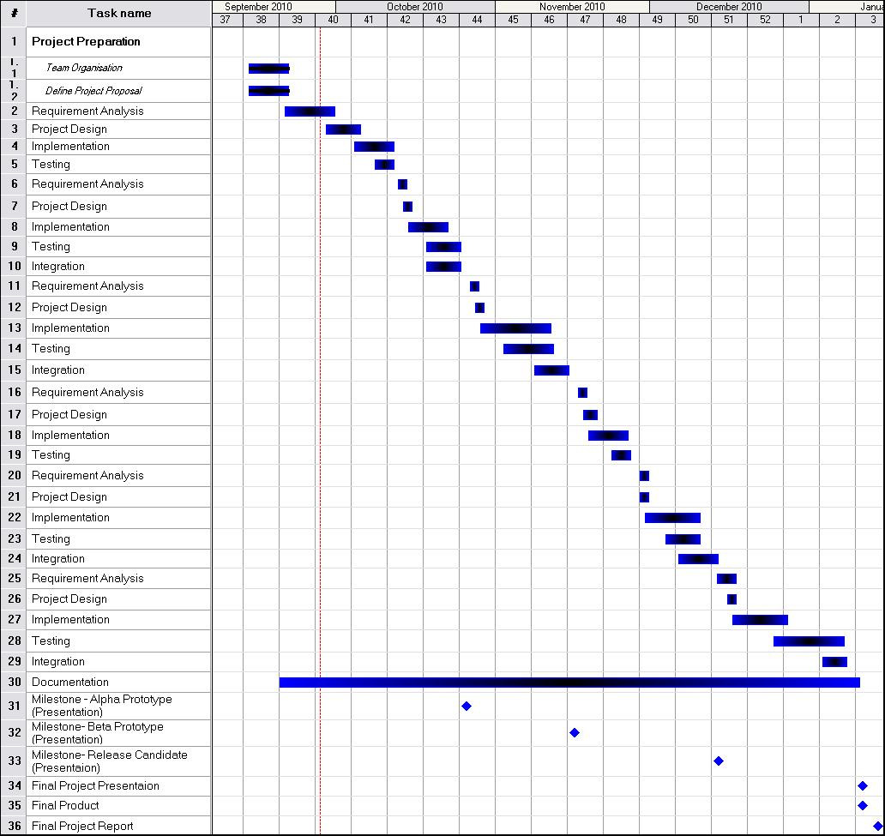

Page 9

EzFare-Transport4you2 | Version: 1.02
Project Description | Date: 2010-10-01

9.3 Financial Plan

Activity | Volume  (days) | Cost | Rem.
Project Management | 15 | 1800
Graphical User Interface | 08 | 960
Web Application | 40 | 4800
Mobile App & Mainframe App | 62 | 7440
Database Management | 10 | 1200
Documentation | 15 | 1800
Integration | 24 | 2880
Testing | 25 | 3000

Planned effort (man-days) | Man-day cost | Planned project cost (100%)
199 | 120€ | 23880€

9.3.1 Remarks

Remark  Id | Description

Page 10

